

**College of Engineering**

**CMPT 661 – Web Development**

**December 3, 2017**

**Project Phase 1 – Admission Module**

**Nada Mahmoud Aboueata - 200900288**

**Sara Yaqoob Al-Rasbi – 200909464**

**Rahma Saleh Ali – 201001782**

## Use Case Diagram

A close up of a map

Description generated with high confidence

|  |  |
| --- | --- |
| Use Case | Description |
| Login | Allows the user to login to his account. This use case must be fulfilled before the user can further interact with the system. |
| Register applicant | Allows the applicant to register an account |
| Update applicant | Allows the applicant to update his details |
| Add application | Allows the applicant to submit an application |
| Get applications | Returns a list of applications submitted by the applicant |
| View application | Allows the user to view a non-editable view of the application |
| Withdraw application | Allows the applicant to withdraw an application |
| Update application | Allows the user to update an application |
| Add attachment | Allows the user to add an attachment to an application |
| Add notes | Allow the user to add a note to the application |

## Class Diagram

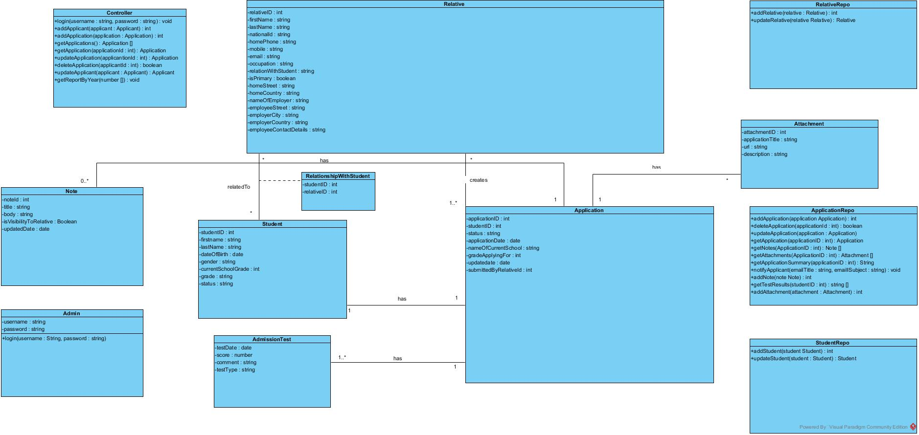

## UI Design

## SMS Main Page

This page is the main page and provides two main functionalities, login and register.

## Login

The user can login either as applicant or as an admin as shown in Figure 1. Based on each role, the index page will be rendered accordingly. Figure 4 and 6 shows the index page of each role.

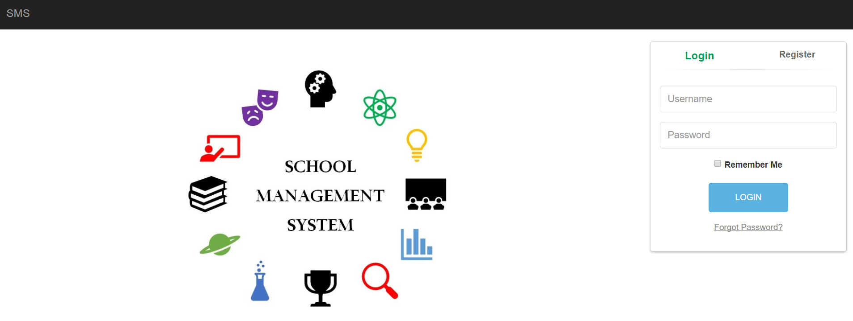

Figure 1- Login Form

## Register

The applicant can register via the form that appears when the register link is clicked as shown in Figure 2. Once the applicant provides the email address and password and submits the form by clicking on Register Now button, the user will be redirected to the applicant registration form, as shown in Figure 3.

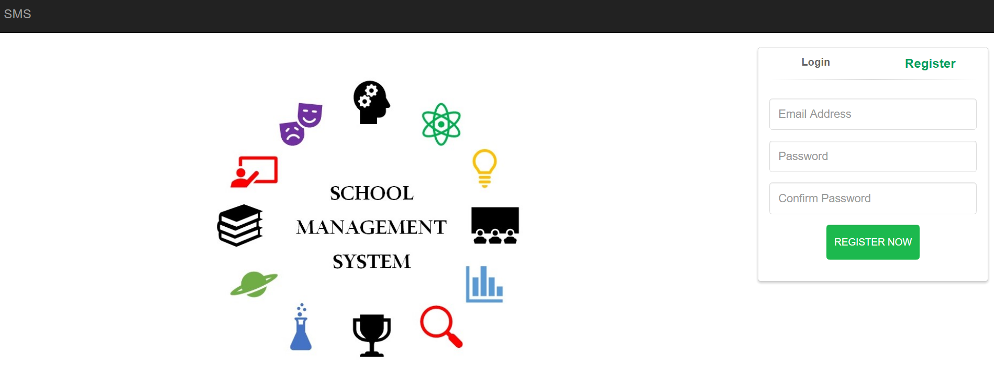

Figure 2- Register Form

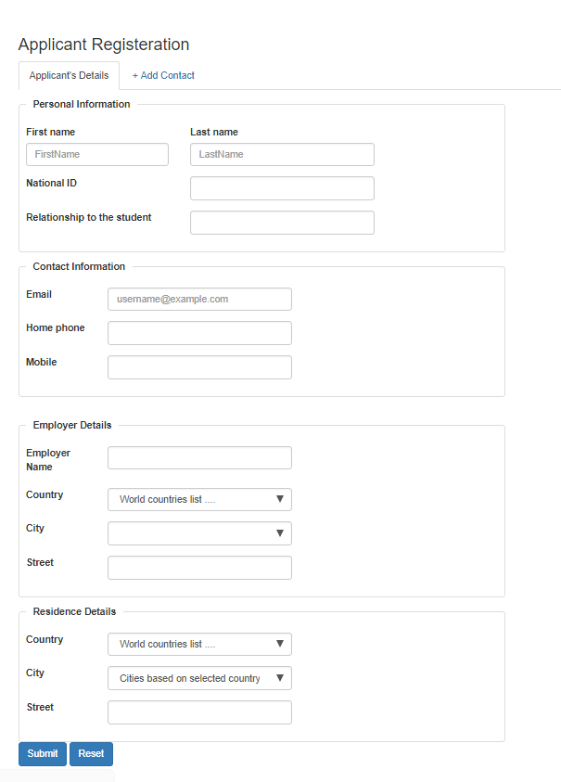

Figure 3- Applicant Registration Form

## SMS Index Page

As mentioned earlier, the index page will be rendered based on the logged in user role as shown in below subsections.

## Applicant Index Page

Figure 4 shows the index page as displayed to an applicant. In this page, the applicant can view, edit/update, delete, add attachment to, and add notes to applications. View application button will display a popup window which will include all the application information in an un-editable format. Edit/update Application, will use the same form that is used for adding application as shown in Figure 7 and Figure 8. Both add attachment and add notes will display a popup window as shown in Figure 5.

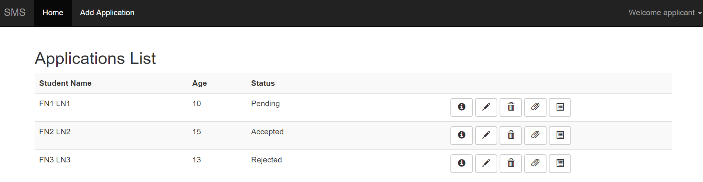

Figure 4- Applicant Index Page

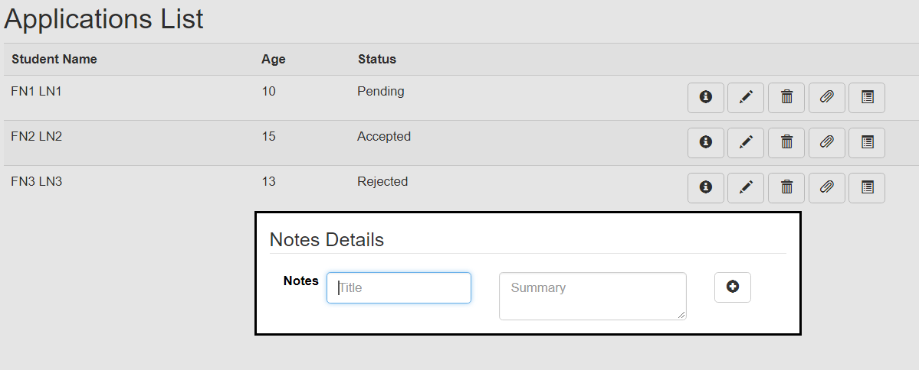

Figure 5- Notes popup

## Admin Index Page

Figure 6 shows the index page as displayed to a logged in admin. In this page, the admin can access the generate reports module or the module to manage applications by clicking on the images Reports or Applications respectively. Another way the admin can do that is via the menu tab Modules when clicked on displays a dropdown menu for redirection to Reports and Applications. Each module will be explained further in the next sections.

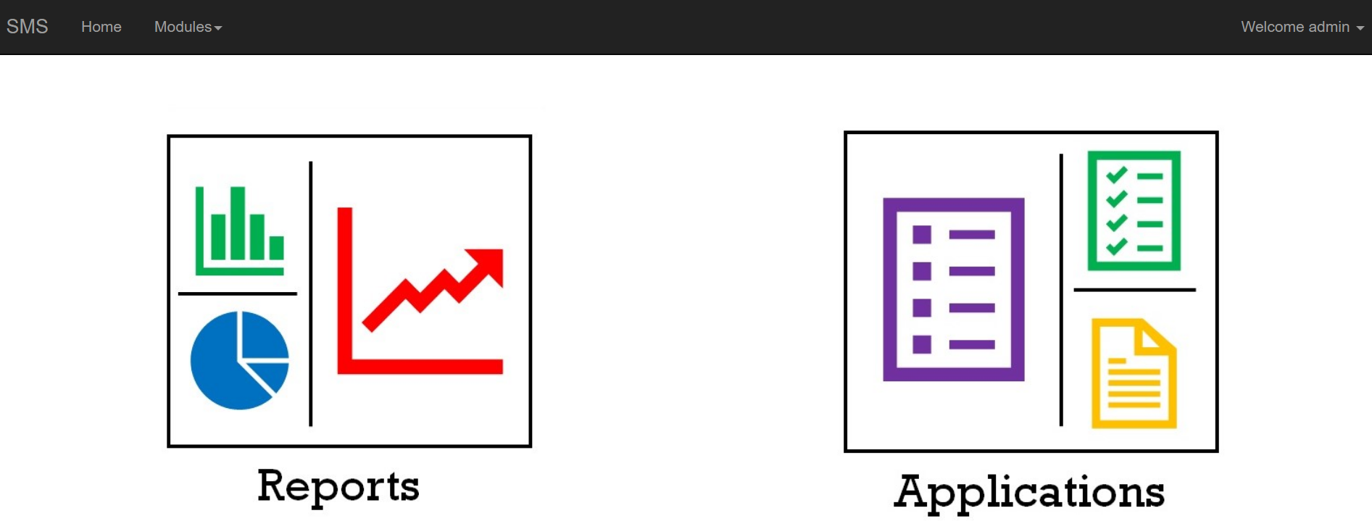

Figure 6- Admin Index Page

## Add/Update Application

Applicant can add and update existing application by using the forms shown below in Figure 7 and Figure 8.

Figure 8- Update Application

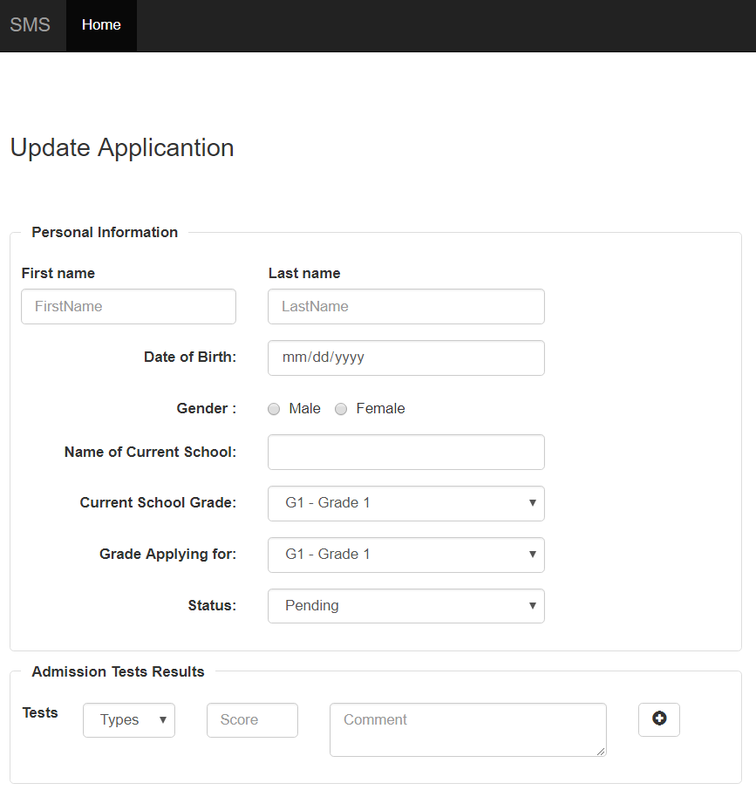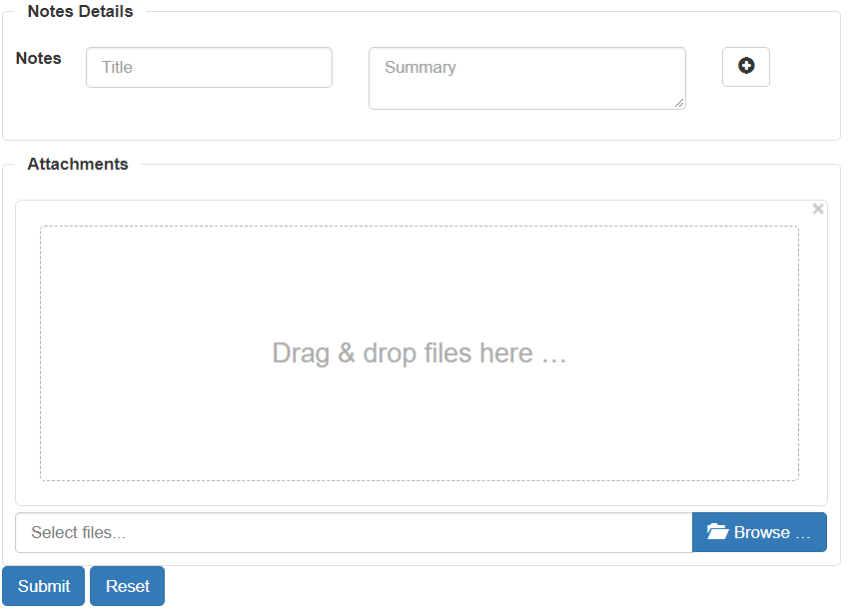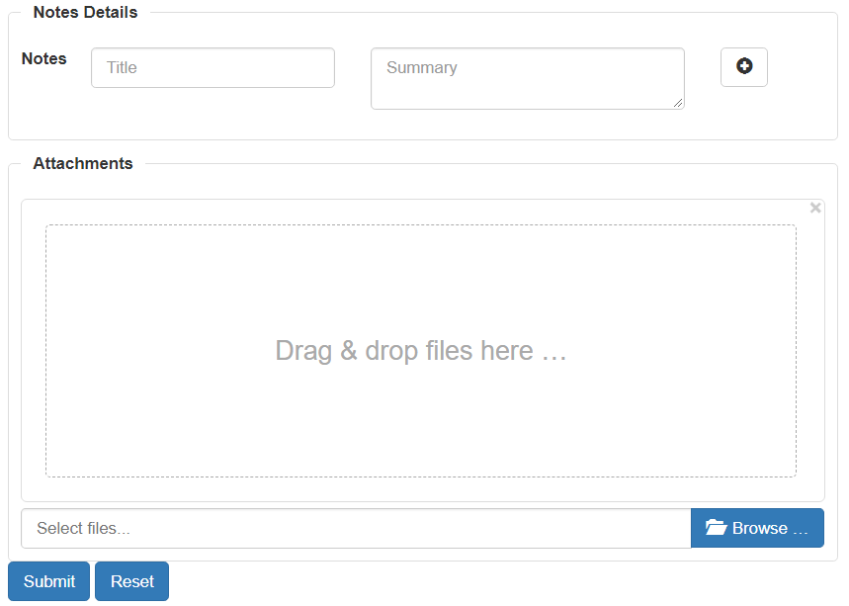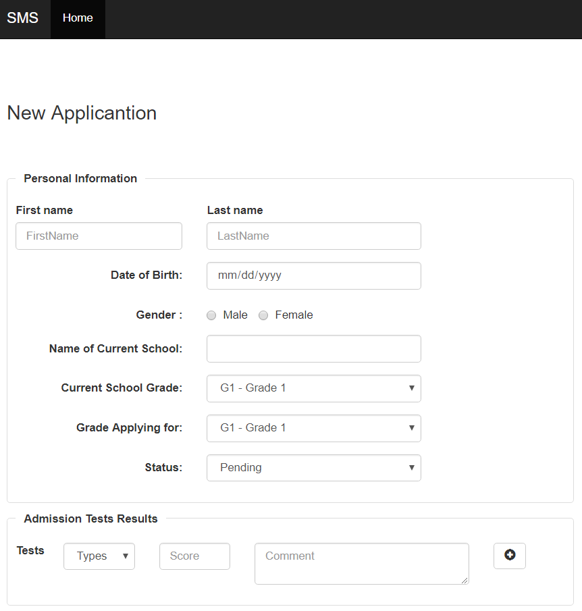

Figure 7- Add Application

## Update Profile

Applicants can update their profile using below form. Once the applicant clicks on profile, they will be redirected to the Update Applicant Profile form as shown in below figure.

Figure 9- Update Applicant

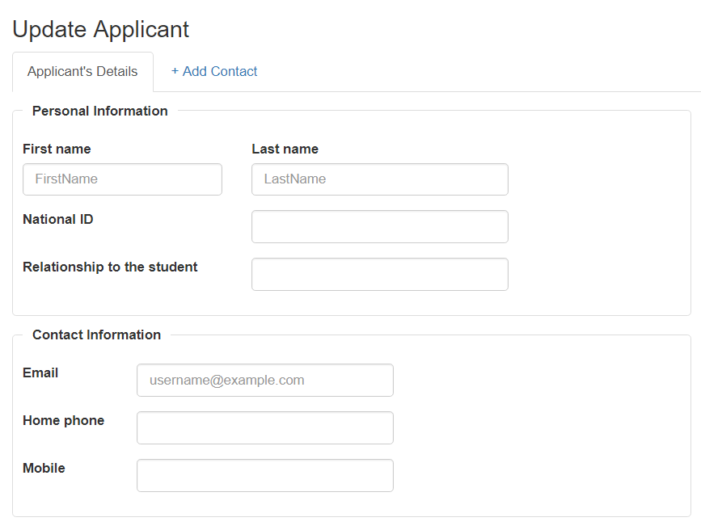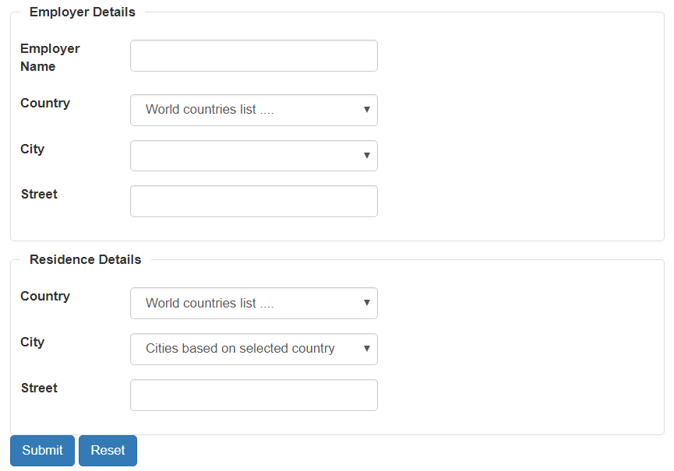

# Generate Report Module

In this module, the admin can select a range for the academic year and a report for the selected years will be displayed per grade.

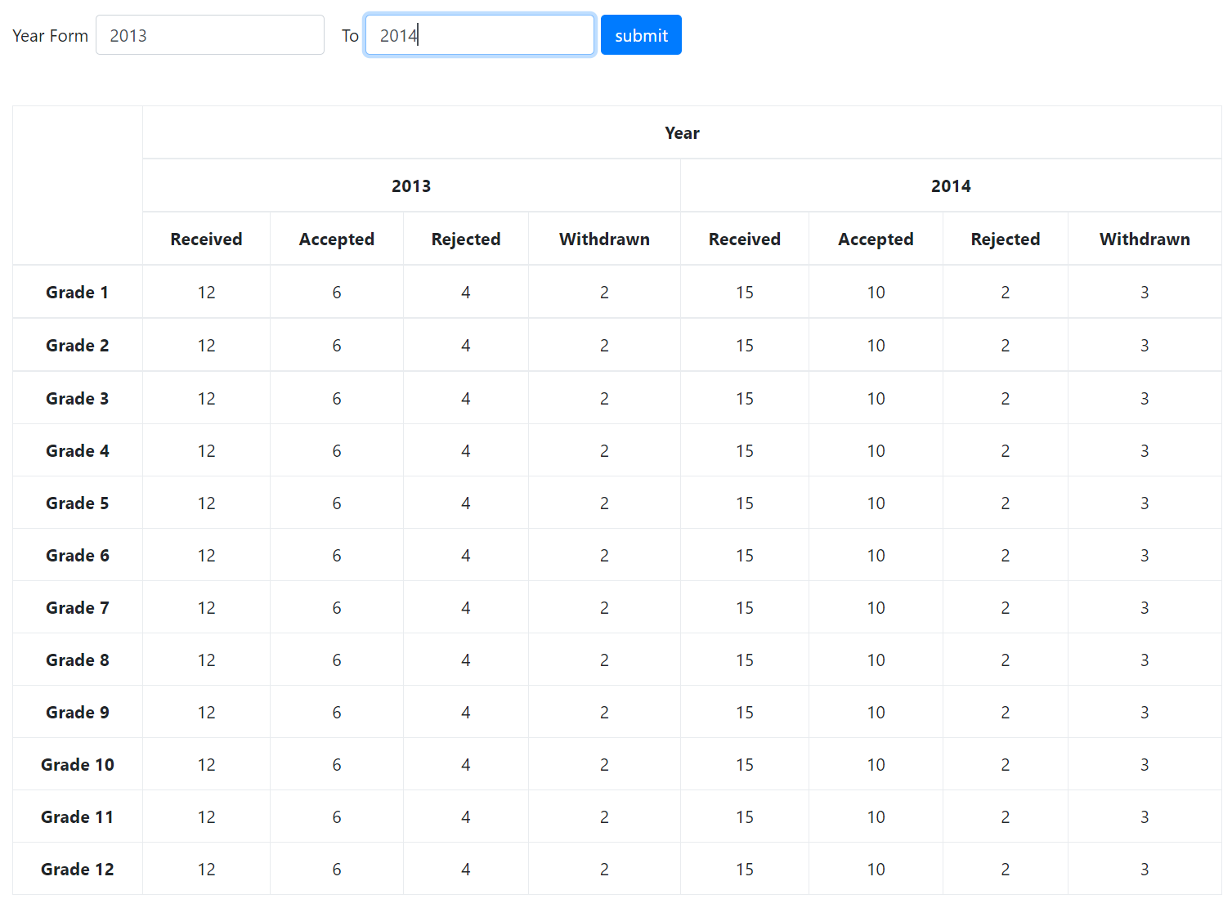

Figure 10- Report Page

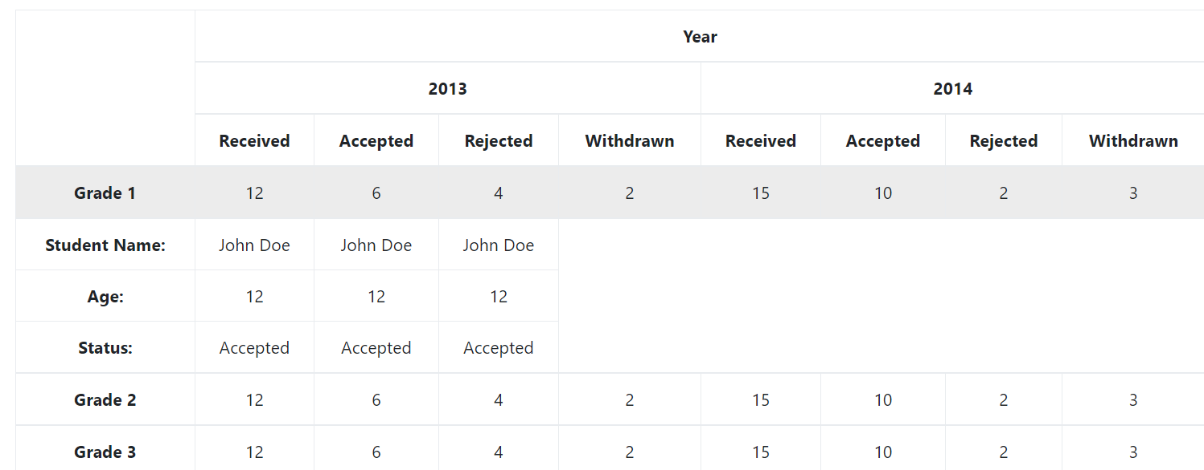When the admin clicks on a cell, the applications details will be displayed.

Figure 11- Report Expandable list